API Documentation

Endpoint <http://localhost:3000/pricing>

Body-{

  "zone": "central",

  "organization_id": "005",

  "total_distance": 6,

  "item_type": "non-perishable"

}

Endpoint:- <http://localhost:3000/pricing>

Body:- {

  "zone": "central",

  "organization_id": "005",

  "total_distance": 12,

  "item_type": "perishable"

}

1. If Organization id is not mentioned

Body-{

  "zone": "central",

//   "organization_id": "008",

  "total_distance": 12,

  "item_type": "perishable"

}

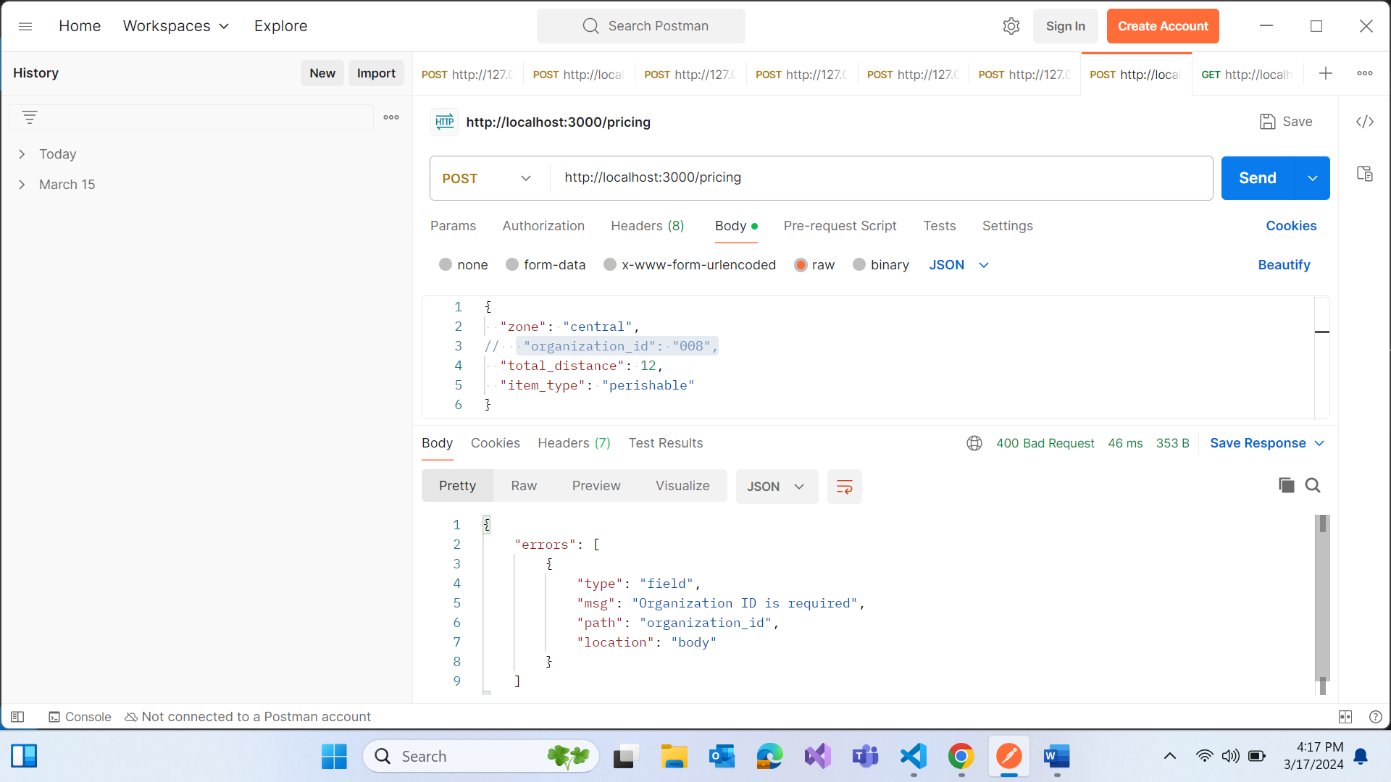

1. If organization id and item id is missed

